

Proposal for
LKR Convention Center
Commercial
| 50.00 kWp Ongrid Rooftop Solar Plant |

Client | Kalyan Reddy
Location | AndhraPradesh
Proposed Solar Capacity | 50 kWp On grid Rooftop Solar Plant

Our Company Overview

Sesola Power Projects Pvt Ltd, operating under the brand Sesola Energy, is a leading Engineering, Procurement, and Construction (EPC) company established in 2017, specializing in solar and power infrastructure solutions.

The company delivers end-to-end turnkey solutions covering design, engineering, procurement, installation, testing, and commissioning of solar power projects, with a strong focus on quality, efficiency, and sustainability.

With a commitment to innovation and performance, Sesola provides advanced solar systems that maximize energy generation and reduce operational costs for clients.
Sesola has cumulatively completed over 300 MW of solar power projects across India, demonstrating its strong execution capability, technical expertise, and trusted industry presence.

Our Expertise

Sesola has developed strong expertise in multiple domains of renewable energy and electrical infrastructure:
- Rooftop Solar Projects
- Ground Mounted Solar Plants
- Floating Solar Systems
- Solar Carports
- Substations & Transmission Lines: Successfully completed execution of 132 kV substations
and 220 kV transmission lines.
- Electrical Infrastructure Works
The company also undertakes LT/HT panel installation, electrification works, and power distribution systems for industries, hospitals, and commercial facilities.

EPC Capabilities

Sesola offers complete turnkey EPC services, ensuring seamless execution of projects:
- Detailed Engineering & Design
- Procurement of Tier-1 Equipment
- Civil & Electrical Installation
- Testing & Commissioning
- Grid Synchronization & Net Metering

Each project is customized to client requirements to ensure maximum efficiency, cost optimization, and long-term performance.

Innovation & R&D

Sesola Energy emphasizes continuous innovation through its Research & Development (R&D) division, focusing on:
- Improving system efficiency
- Developing advanced solar technologies
- Enhancing performance and durability
- Delivering cost-effective energy solutions
This commitment ensures the company stays ahead in the evolving renewable energy sector.

Global Presence:

Headquartered in Hyderabad, India, Sesola has expanded its footprint internationally, executing projects in:
- Dubai
- Singapore
This global exposure enables the company to handle diverse project requirements and regulatory environments with high efficiency.

Safety & Quality Commitment:

At Sesola Power Projects Pvt Ltd, safety is a core priority in all phases of project execution. We strictly adhere to industry safety standards and best practices to ensure a safe working environment for our workforce and stakeholders.
Our safety practices include:
- Implementation of standard safety protocols at all project sites
- Use of Personal Protective Equipment (PPE) for all personnel
- Regular safety training and toolbox talks for workers
- Compliance with electrical and structural safety standards
- Routine inspections and risk assessments
We are committed to achieving zero-incident project execution while maintaining the highest levels of quality and operational excellence.

Our Sample PROJECT EXECUTION / INSTALLATION WORKS
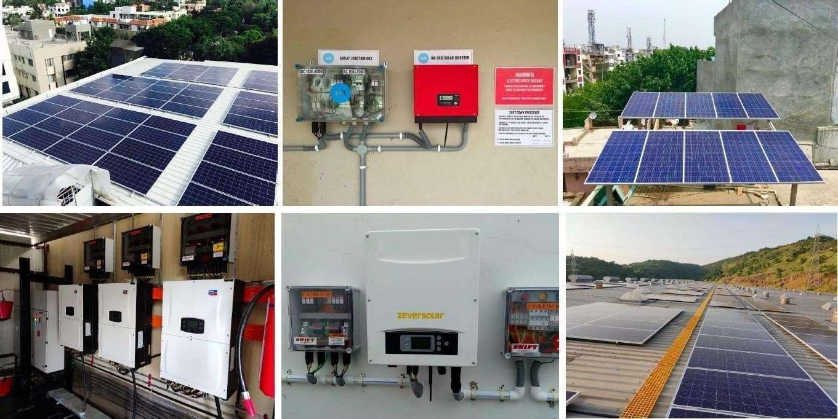
About the System
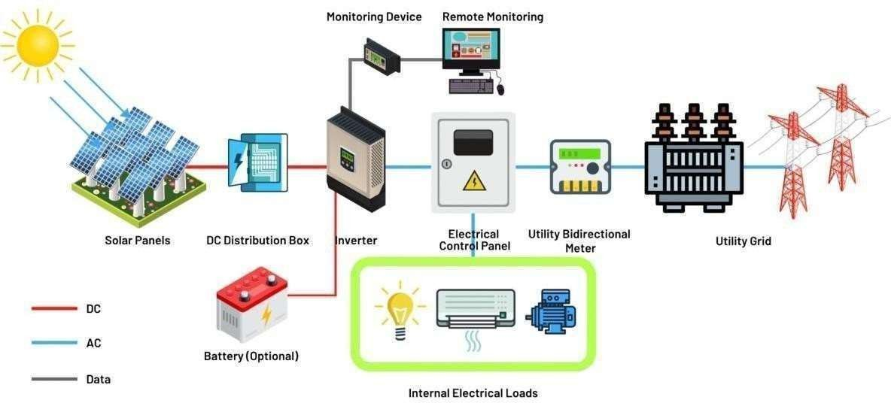

How Net Metering Works
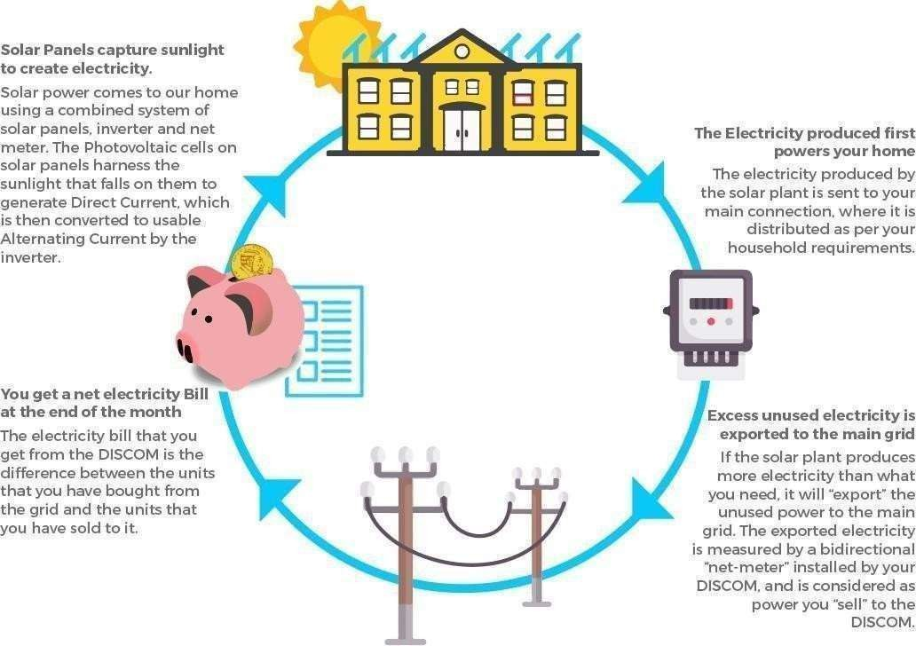
Financial Pricing

S.No | Description of Work | Price for 50 kWp Plant | GST  % | GST  Amount | Total Cost
1 | 50 kWp Rooftop Solar PV Plant with DCR panels | ₹26,07,897 | 8.9% | ₹2,32,103 | ₹28,40,000

Amount in Words: Twenty Eight Lakhs Forty Thousand Rupees Only.

Note:
- Quote valid for 10 days from Friday(12-06-26).
- Estimated ROI (Return on Investment) period is approximately 4 to 5 years based on average power consumption and generation conditions.
- Net Metering and CEIG process is in SESOLA scope.
- Banking process and EB related documentation support from customer side will be required wherever applicable.
- Transportation included.
- Project execution timeline: 30 to 45 working days from date of advance payment and approval.
- Warranty:
  - Solar Modules: 25 years
  - Inverter: 8 years
  - Installation workmanship warranty by SESOLA as applicable.

Bill of Material

Sl. No | Component | Specifications | Make | Qty | Units
1 | PV Modules | 590Wp & Above N Type TOPCON Bifacial DCR Modules | SWELECT/ JAKSON | 85 | No's
2 | Inverter | 50kW Single Phase Grid Tie inverter | POLYCAB | 1 | No's
3 | DCDB | * PC Enclosure with IP 65 Protection * DC Type 2 SPD - 600 V * I/C & O/C 40A DC fuse in positive (1 in 1 out) * I/C & O/C Terminal Block negative * DC MCCB | L&T / ABB | 1 | No's
4 | ACDB | * IP 65 Indoor Polycarbonate Enclosure * AC Type 2 SPD * 50 A 2 pole AC MCCB with MFM meter  compatible with RS485 Port | L&T/ ABB | 1 | No's
5 | Structures | Aluminium Structure | KAMPSOL | 1 | Set
6 | Connectors | Solar MC4 Connectors (1500 V 30A) | NINGBO | 50 | Pairs
7 | DC Cable | 1C*6 sq mm DC Cable (75 R + 75 B) | POLYCAB | 150 | Meters
8 | AC Cable | 4C* 50 sq mm, multi strand Aluminium Armoured AC Cable From inverter to client panel | POLYCAB | 100 | Meters
9 | Earthing cable | 1C*4 sq mm Cu Green Flexible cable | POLYCAB | 250 | Meters
10 | Lightning Arrestor | Conventional type, multi spike, 1 meter LA | EXCEL | 1 | No's
11 | Earth Rod | 14 mm Dia, 1 mt long, 100 microns copper bonded earth Rod | EXCEL | 4 | No's
12 | Chemical Bag | 10 kg carbaneous bag | EXCEL | 5 | No's
13 | Earth Chamber | 18*18 cm FRP earth bit chamber with cover | EXCEL | 5 | No's
14 | Lugs | 4 sq mm Ring type lugs | STANDARD | 10 | No's

15 | Lugs | 4 sq mm Pin type lugs | STANDARD | 8 | No's
16 | Cable Tie | UV Protected 200 mm cable tie | STANDARD | 30 | Piece
17 | PVC Pipes | 25 mm PVC black ISI pipe heavy duty with 25 mm bend, clamp, fisher and screws | AEROPLAST | 40 | Meters
18 | Insulation Tapes | Supply of Insulation tape (R, Y, B) | STANDARD | 3 | No's
19 | Trunking Profile | 45*45 PVC Trunking Profile | AEROPLAST | 1 | No's

Thanks & Regards,

For Sesola Power Projects Pvt. Ltd.

Sudhakar G
+91-7013759123
Executive Manager – Procurement

